

School of Computing, Engineering & Physical Sciences
MSc IT with Data Analytics
Interim Report

Improving Music Popularity Prediction by using Advanced Feature Selection and Interactive Visualization
by
Asma Imtiaz
B01799642
Date of submission: <03/11/2025>
Supervisor: Raja Ujjan
Moderator: Jamal Hwidi



DECLARATION OF ORIGINALITY

I declare that this is an original study based on my own
work and that I have not submitted it for any other
course or degree.

Signature_______________________

Table of Contents
1. Introduction and Summary Literature Review 5
1.1. Introduction 5
1.1.1. Project Overview 5
1.1.2. Rationale 5
1.1.3. Goals and Objectives 6
1.2. Summary Literature Review 7
1.2.1. Current Research in Music Popularity Prediction 7
1.2.2. Feature Selection Techniques 8
1.2.3. Visualisation Techniques in Data Science 10
1.2.4. Gap in the Literature 12
2. Research Methodology 12
2.1. Research Design 12
2.1.1. Type of Research 12
2.1.2. Research Process 13
2.2. Data Collection and Analysis 14
2.2.1. Data Collection 14
2.2.2. Dataset Features 15
2.2.3. Data Cleaning and Preprocessing 15
2.2.4. Feature Engineering and Selection 16
2.3. Model Development and Evaluation 17
2.3.1. Machine Learning Models 17
2.3.2. Explainability 19
2.3.3. Metrics for Model Evaluation 20
2.4. Visualisation (Interactive Dashboard) 20
3. Plan for Completion 22
3.1. Current Status 22
3.2. Challenges Faced 23
3.3. Next Steps 23
3.4. Timeline for Completion 24
3.5. Contingency Plan 25
References 26

Introduction and Summary Literature Review

Introduction

Project Overview
In today’s digital music economy, platforms such as Spotify transmit massive volumes of listener-engagement data, creating opportunities for predictive modelling of track popularity. Recent studies demonstrate the feasibility of predicting whether a song will achieve success (e.g., high stream counts or chart inclusion) through supervised machine learning (ML) using audio features, metadata and engagement metrics. For example, a study using Spotify audio features found that classification/regression models (e.g., Extra Trees and Random Forest) achieved strong predictive performance with a dataset of ~92,755 songs (Saragih, 2023).
My project “Improving Music Popularity Prediction by using Advanced Feature Selection and Interactive Visualisation” aims to advance this domain in two key ways. First, it will investigate how different feature-selection techniques (filter, wrapper, embedded) impact the robustness and accuracy of ML algorithms in predicting popularity on Spotify. Second, it will develop an interactive dashboard (via Tableau) to visualise the effects of feature-selection, model performance and key drivers of popularity for stakeholders.

Rationale
Predicting music popularity is of considerable interest to artists, record labels, and streaming platforms, as well as in making decisions such as release timing, marketing allocation, and playlist promotion. While previous research has shown promising accuracy, key gaps remain. For instance, the work by Khan et al. (2022) reports only a basic filter-based feature selection (removing features with correlation below 0.02) and observes negligible loss in accuracy (95.15% → 95.14%). Yet that study a) does not explore more advanced feature-selection approaches (e.g., wrappers, embedded methods) in depth; b) omits richer contextual features such as genre, regional listener patterns, artist-fan network metrics; and c) provides limited visual interpretation of how selected features influence model outcomes. Meanwhile, more recent works indicate that model performance still varies significantly across datasets and feature sets (e.g., studies for Indonesia streamed songs).
Accordingly, there is a need for a deeper empirical investigation of which features actually matter, how feature-selection affects performance and generalisability, and how stakeholders can meaningfully interpret and interact with these findings. My project seeks to fill that gap by combining advanced feature‐selection, multiple ML algorithms (including ensembles and neural nets), comprehensive evaluation (accuracy, precision, recall, F1-score, ROC-AUC) and a stakeholder-oriented visual analytics layer.

Goals and Objectives
Aim: To conduct a detailed feature-level analysis and build an interactive dashboard for improved prediction of music popularity on Spotify — thereby extending prior work and enabling actionable insights.
Objectives:
- Data Collection & Preparation: To gather a dataset combining Spotify Web API metadata and a Kaggle dataset of tracks; perform cleaning, preprocessing and feature engineering (including genre, region, artist metrics).
- Exploratory Data Analysis (EDA): To analyse distributions, correlations and feature relationships to identify potential predictors and prepare for feature‐selection.
- Model Development: To train and compare multiple machine-learning models (Random Forest, Gradient Boosting (XGBoost/LightGBM), Neural Network) with hyperparameter tuning.
- Explainability: To apply explainability methods (e.g., SHAP, LIME) to identify which features contribute most materially to model predictions and thereby inform feature-selection iterations.
- Visual Analytics: To build an interactive Tableau dashboard enabling stakeholders to explore feature importance, popularity distributions, model outcomes and scenario analysis.
- Evaluation: To assess model performance across various metrics (accuracy, precision, recall, F1-score, ROC-AUC), compare performance across different feature‐selection strategies, and benchmark against prior studies.
- Critical Review & Reflection: To reflect on limitations (data bias, model generalisability), ethical considerations (e.g., algorithmic fairness in music recommendation), and implications for industry practice.

Summary Literature Review

Current Research in Music Popularity Prediction
Predicting music popularity has gained increasing attention as streaming platforms (such as Spotify) amass large volumes of listener engagement data. Recent studies explore machine-learning models that utilise audio features, metadata and social signals to forecast which songs will become popular. For instance, Predicting song popularity based on Spotify’s audio features: insights from the Indonesian streaming users by Saragih (2023) uses a Spotify dataset of 92,755 tracks and finds that Extra Trees Regressor and Random Forest Classifier achieved the highest prediction performance. Another study, Leveraging Artificial Intelligence for Predicting Music Popularity Using Social Media, merges audio features and social-media metrics via a novel DHB-ILSTM (Dynamic Honey Badger Optimization-driven LSTM) model, reporting accuracy of ~93 % (Wu, 2025).
Despite these advances, several studies caution that prediction remains a challenging problem. For example, Kapoor and Narayanan (2023) argue that many claims of high accuracy are overly-optimistic or rely on limited datasets.
More recently, deep learning approaches have emerged: a work on convolutional neural networks for track popularity indicates that while audio-feature-driven CNNs yield moderate gains, they confirm that accurately modelling the “hit” nature of songs remains elusive (Falah, Yousefimehr and Ghatee, 2025).
In sum, current research demonstrates that:
- Traditional machine-learning models (Random Forest, Extra Trees, Gradient Boosting) applied to audio/metadata features achieve respectable performance (Saragih 2023).
- Incorporation of social-media and non-audio signals appears beneficial (Wu 2024).
- Deep learning architectures are being explored, but the “hit” prediction remains hard to generalise (Kapoor and Narayanan, 2023).
- Datasets are becoming more diverse, yet comparative feature-selection analyses and stakeholder-friendly visualisations remain rare.

Feature Selection Techniques
Feature selection is a critical preprocessing step in machine-learning pipelines: it serves to reduce dimensionality, eliminate redundant or irrelevant features, mitigate overfitting and improve model interpretability (Cheng, 2025).
Feature-selection methods are commonly categorised into three broad types: Filter , Wrapper, and Embedded (Krishna, 2025).
Filter methods rely on statistical properties of features (e.g., correlation, mutual information, variance thresholds) independent of any given model.
Wrapper methods evaluate subsets of features using model-training performance (e.g., recursive feature elimination, forward/backward selection) and tend to produce stronger feature‐subsets at the cost of higher computation.
Embedded methods integrate feature selection within the model-training process (e.g., LASSO regularisation, tree-based feature importance in Random Forest, XGBoost).
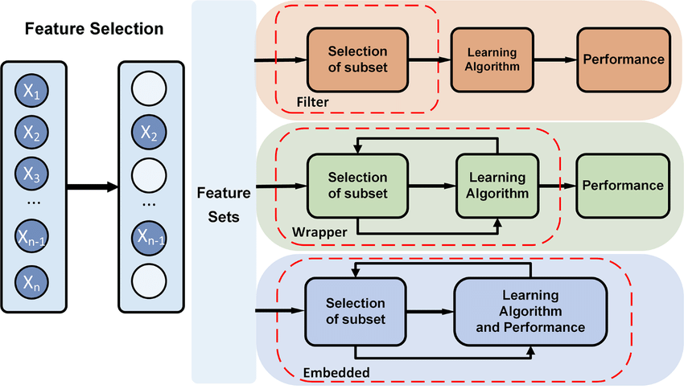
Figure 1 Feature Selection Methods in Music Popularity Prediction (Krishna, 2025)
Figure 1 shows the typical stages of feature selection (filter → wrapper → embedded) and how they interface with model building and evaluation. A comprehensive review by Taha, Abdullah and Rashid (2024) emphasises that hybrid and meta-heuristic techniques (such as genetic algorithms) are emerging as promising directions for large and complex datasets.
Despite general reviews, the specific application of feature-selection methods in music-popularity prediction is under-explored. For example, studies such as Saragih (2023) report feature importance (via tree models) but do not experimentally compare multiple feature-selection strategies across different models. In the domain of music popularity prediction, effective feature selection could help identify which audio/metadata/social features matter most (e.g., genre, tempo, release date, social-media buzz), improve model robustness and generalisability across regions/cultures and reduce model complexity and facilitate interpretability for stakeholders (e.g., via dashboards).
Thus, exploring advanced feature-selection and comparing how different methods affect model performance is a meaningful research direction for my project.

Visualisation Techniques in Data Science
Interactive visual analytics and dashboards are vital in translating analytical insights into stakeholder-actionable formats. According to research by Hoffenson et al. (2023), the design and interactivity of dashboards significantly impact decision-making effectiveness. A recent paper by Myakala, Bura and Juma (2024) examines user-centred design, data integration, performance optimisation and security in dashboards across domains.
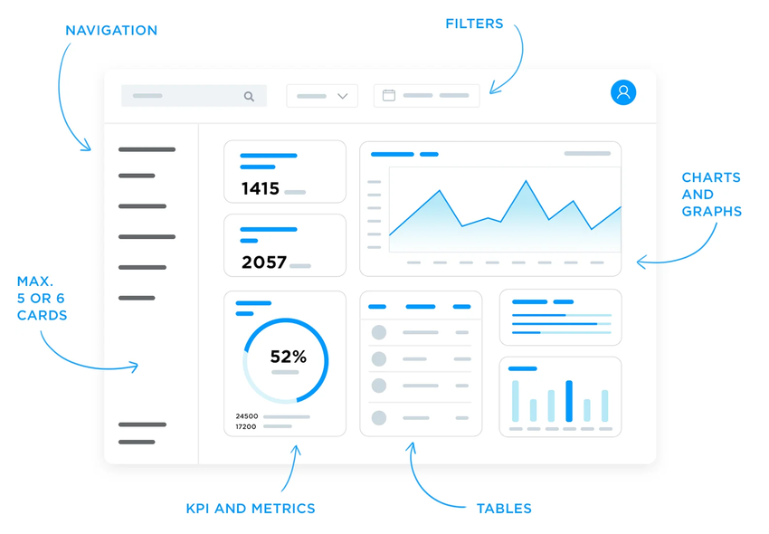
Figure 2 Sample of a modern interactive dashboard layout with KPIs (Myakala, Bura and Juma, 2024)
In the domain of data science and business intelligence, tools such as Tableau, Power BI, and open-source libraries (Dash, Plotly) are widely used (Luna, 2023). An applied thesis in market-research demonstrated that interactive dashboards improved stakeholder understanding of complex survey data, emphasising filtering, drill-down and visual storytelling features (Zare, 2022).
For music-popularity prediction, a dashboard could enable stakeholders (artists, labels, streaming platforms) to:
- Explore feature importance (which variables drive popularity).
- Compare model performance under different feature-selection scenarios.
- Visualise regional/genre-specific popularity trends.
The combination of ML modelling and interactive visualisation bridges two gaps: technical performance and stakeholder interpretability.
Table 1: Overview of Selected Recent Studies in Music Popularity Prediction
Study | Dataset & Features | Models Used | Key Findings
Saragih (2023) | 92,755 songs from Spotify (Indonesia); audio features only | Extra Trees Regressor, Random Forest Classifier | Tree models performed best; audio features are predictive, but genre/context is not deeply explored.
Wu (2024) | Combined audio+social-media signals; new dataset | DHB-ILSTM (custom hybrid model) | ~93 % accuracy; demonstrates the value of social-media plus audio features
Mountzouris (2025) | Large streaming dataset; chart inclusion prediction | Logistic Regression, Random Forest, XGBoost | ~90 % accuracy; genre & speechiness strong predictors; still challenging to generalise
Jiang (2024) | 114,000 songs over two decades (Spotify) | ML algorithms (various) | Confirms predictive potential of large audio/metadata sets; stress on generalisation.

Gap in the Literature
Despite the progress in music-popularity modelling, several gaps remain: While many studies report feature importance (e.g., Saragih 2023), few systematically compare filter vs wrapper vs embedded methods in the music-popularity domain. Many works rely primarily on audio features and basic metadata; less attention is paid to genres, artist networks, social-media signals and regional listener behaviour (Wu 2024), which my project aims to include.
Although dashboards are widely covered in the data-science literature, their use in music-analytics research is minimal. There is limited work showing how insights from feature-selection and model performance can be visualised in interactive dashboards for decision-making. Some cautionary studies argue that model performance achieved on one dataset doesn’t always transfer to others – indicating a lack of robustness across regions or time (Kapoor and Narayanan, 2023). Although tools like SHAP/LIME are emerging in general ML literature, their application to music-popularity prediction (and visualisation of their results) remains under-explored.
Given these gaps, my research aims to extend the literature by performing an in-depth feature-selection experiment, comparing multiple ML models, and building an interactive dashboard.

Research Methodology

Research Design

Type of Research
This study employs a quantitative, data‐driven research design combining machine learning (ML) with automated feature‐selection techniques and interactive visualisation. Specifically, it is structured as applied research in music analytics: we seek to predict track popularity on the Spotify platform using a large dataset of audio and metadata features and then interpret and visualise the impact of different features using dashboards for stakeholders. The core of the research is supervised learning, treating track popularity (0-100 scale) as a target variable, and comparing how different feature-selection strategies (filter, wrapper, embedded) affect forecasting robustness and accuracy. The research also integrates explainability methods (e.g., SHAP, LIME) to enhance the transparency of the ML models and then presents findings via an interactive dashboard. In recent works, such as Wu (2024) in Profesional de la Información, deep learning and social media metrics were used for music‐popularity prediction with ~93 % accuracy, demonstrating the viability of the approach.
Furthermore, the study by Jiang (2024) on a Spotify dataset of 114,000 songs compared Random Forest and Gradient Boosting, emphasising the importance of feature selection in capturing audio features such as danceability, energy, and loudness. These underscore both the feasibility and relevance of the method.

Research Process
The research process for predicting music popularity consists of the following steps:
- Data Collection: The main data will be Spotify 1 Million Tracks (Joshi, Parolkar & Das, 2023), which can be described as including audio parameters (danceability, energy, loudness, etc.) and popularity ratings. To further enrich the data, additional metadata, including the information about the followers of the artists and genres, will be retrieved with the help of the Spotify Web API.
- Data Cleaning: Any frequency of the absence of values will be addressed with imputation or the deletion of duplicates. The outliers of such aspects of features as loudness or tempo will be dealt with by means such as the z-score or the IQR. The continuous variables will be standardised/min-max-scaled, and the categorical variable will be one-hot-encoded/label-encoded.
- Feature Engineering and Selection: the new features will be made to be interaction terms (e.g., energy × tempo), and features based on time, e.g. year of release. Filter, wrapper, and embedded feature selection methods will be used to determine the most significant features that may be used in predicting popularity.
- Model Development: Three machine learning models will be trained and assessed: Random Forest (RF), Gradient Boosting Machines (XGBoost/LightGBM) and Artificial Neural Networks (ANN). Such models will be picked according to their ability to process high-dimensional and structured information.
- Explainability: SHAP and LIME will be employed to derive information about the importance of features and get a better insight into how models have been made, which will increase transparency.
- Model Evaluation: Model performance will be assessed based on accuracy, precision, recall, F1-score, and ROC-AUC on classification, R 2, and RMSE on regression.
- Visualisation: An interactive Tableau dashboard will be developed to enable the stakeholders to interactively analyse the model results, the importance of features and trends of tracks' popularity.

Data Collection and Analysis

Data Collection
The main data used in this research is the Spotify 1 Million Tracks Dataset (Joshi, Parolkar, and Das, 2023), offered by Kaggle. The dataset contains an extensive variety of audio-related features, including danceability, energy, loudness, valence, tempo, and others, as well as the popularity measured on a scale of 0 to 100. The target variable is the popularity score.
In order to make this dataset even richer and get more context, the Spotify Web API will be utilised to retrieve the metadata about the tracks, such as the number of artists' followers, the genre tags, and the region of release.

Dataset Features
The key features in the dataset are as follows:
Audio Features | Description
Popularity | Track popularity (0 to 100)
Year | Year released (2000 to 2023)
Danceability | Track suitability for dancing (0.0 to 1.0)
Energy | The perceptual measure of intensity and activity (0.0 to 1.0)
Key | The key to the track is in (-1 to -11)
Loudness | Overall loudness of the track in decibels (-60 to 0 dB)
Mode | Modality of the track (Major ‘1’/Minor ‘0’)
Speechiness | Presence of spoken words in the track
Acousticness | Confidence measure from 0 to 1 of whether the track is acoustic
Instrumentalness | Whether the track contains vocals (0.0 to 1.0)
Liveness | Presence of audience in the recording (0.0 to 1.0)
Valence | Musical positiveness (0.0 to 1.0)
Tempo | Tempo of the track in beats per minute (BPM)
Time_signature | Estimated time signature (3 to 7)
Duration_ms | Duration of track in milliseconds

Data Cleaning and Preprocessing
Data cleaning follows a number of processes to prepare the data for analysis. The initial one is the identification and treatment of missing values that can be experienced by some of the features within the dataset. The missing values will be filled in or deleted depending on the amount of missing data being large or small, respectively, using the mean imputation method or deletion. Duplicates will also be verified, and any redundant records will be eliminated. Also, the presence of outliers in numerical variables (e.g., loudness, tempo, etc.) will also be detected and identified.

Feature Engineering and Selection
During the feature engineering stage, additional features will be designed to augment the data. This may involve interaction terms like energy x tempo, and this may give insight into how some of the musical attributes interact to create an effect on popularity. Temporal characteristics such as year of release and week of release will be developed in order to capture trends in time. Data provided by the Spotify Web API will also be used to add artist-level metrics (e.g., artist followers, diversity of their genres).
In the process of selecting features, varied approaches will be used to determine the most significant features. The filter method will remove features that have either high variance or low correlation with the target variable. Lastly, built-in techniques will be used, such as the scores of feature importance of tree-based designs like Random Forest and XGBoost, or L1-regularisation of logistic regression.

Model Development and Evaluation

Machine Learning Models
For the predictive modelling of track popularity in my project, three main classes of machine learning algorithms are selected: Random Forest (RF), Gradient Boosting Machines (GBM/XGBoost/LightGBM), and Artificial Neural Networks (ANNs). These choices are grounded in recent literature on music-popularity prediction and general best practice for structured/tabular data.
Random Forest (RF): RF is an ensemble of decision trees using bootstrap aggregation (bagging) and random feature sampling. It is favoured for its robustness to noisy features, ability to handle high-dimensional data, and strong performance outside the box.
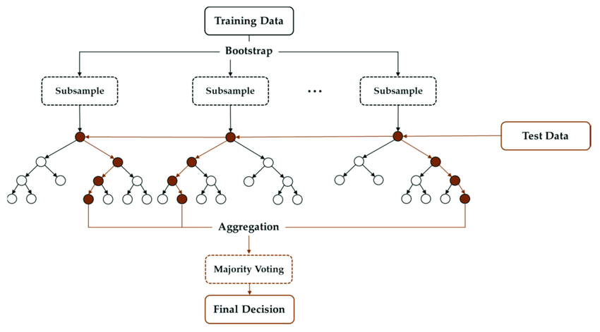
Figure 3 Random Forest (RF) Model (Jeong et al., 2022)
Gradient Boosting Machines (GBM) (including XGBoost/LightGBM): GBM methods build trees sequentially, each new tree correcting residuals from prior trees. This often leads to very high predictive accuracy on structured datasets.
Artificial Neural Networks (ANNs): ANNs (including deep networks) are selected because they can model complex non-linear interactions among features (e.g., how tempo × key × genre might combine to influence popularity) that tree-based models may not fully capture. A recent investigation used a convolutional neural network (CNN) on Spotify features and spectrogram information and achieved an impressive F1-score (97%) in hit‐song prediction (Falah, Yousefimehr and Ghatee, 2025). Incorporating an ANN allows me to assess whether the more conventional tree/boosting approaches suffice, or whether more complex architectures offer improved performance in this domain.
Rationale for Model Selection: Machine learning models were selected for their complementary strengths. Random Forest offers strong baseline performance and interpretability. Gradient Boosting often yields state‐of‐the‐art results on structured prediction tasks by sequentially correcting errors. Neural Networks enable modelling of deeper, non‐linear relationships that simpler models may miss.

Explainability
Explainability methods will be applied to ensure transparency and stakeholder relevance. Specifically, SHAP (SHapley Additive exPlanations) and LIME (Local Interpretable Model-agnostic Explanations) are used.
    - Metrics for Model Evaluation
To evaluate the models and their performance rigorously, a set of established metrics will be used. Depending on whether we frame the problem as regression (predict popularity score) or classification (popular vs non-popular), I will use appropriate metrics.
Regression setting (if predicting popularity as a continuous 0–100 score): Use R² (coefficient of determination) to measure proportion of variance explained; RMSE (Root Mean Squared Error) to measure average error magnitude; MAE (Mean Absolute Error) as a more robust error measure.
Classification setting (e.g., binary popular vs non-popular): Use Accuracy (overall correct predictions), Precision (correct positive predictions vs all positive predictions), Recall (Sensitivity) (correct positive predictions vs all actual positives), F1-Score (harmonic mean of precision and recall, especially useful for imbalanced classes), and ROC-AUC (Area Under the Receiver Operating Characteristic curve) to measure discrimination ability across thresholds. For example, the study by Mountzouris (2025) reported ~90% accuracy and an F1-score of ~0.91 for Random Forest and XGBoost.
In my context, tracking all these metrics allows me to compare not only which model is best, but how sensitive performance is to feature-selection technique.

Visualisation (Interactive Dashboard)
A major interface between the technical modelling project and the stakeholder-focused information in the project will be an interactive dashboard that will be developed using Tableau. As an example, a study conducted by Sivaraj and Singh (2025) highlights that non-technical stakeholders are able to access data because interactive dashboards enable them to move at a rate that is suitable to them and thereby enhance engagement and decision-making.
The dashboard will include the following features and design elements:
- Overview & KPIs: A high-level landing view showing key metrics such as average popularity score, distribution by genre, top artists by follower count, and model performance indicators (accuracy, recall). This aligns with best practice in dashboard design for stakeholder alignment (Sengupta and Singha, 2024).
- Feature Importance Visualisation: A dedicated view drawing on the explainability work (SHAP/LIME).
- Genre/Region Drill-Down: An interactive panel allowing stakeholders to filter by genre, region or artist, and observe how the prediction model behaves under each subset—e.g., popularity distribution, feature importance changes, model performance.
- Scenario/What-If Analysis: A control (a slider, input, etc.), where stakeholders can change the value of the key features (e.g. tempo, danceability, number of artists following, etc.), and the predicted score by the model of how popular the track will be or the probability of the track being popular will change.
- Explainability Details: An option where users are given the ability to choose one particular track and be shown a dissection of how individual features helped to make the prediction by SHAP (global) or local (LIME) explanations. This adds transparency and trust, which are essential to stakeholders' acceptance of predictive systems (Matheus, Janssen and Maheshwari, 2018).
According to the literature, these dashboards enable the availability of intricate model results and allow the parties to recognise the patterns, correlations, and outliers that may be overlooked by manual examination (Matheus, Janssen and Maheswari, 2018).

Plan for Completion

Current Status
The process of data collection has already been successful at this stage. Spotify 1 Million Tracks Dataset was downloaded from Kaggle, and information was effectively retrieved from the Spotify Web API in order to supplement the data with more metadata (artist followers, genre, release region, and so on).
As far as data cleaning is concerned, there are no major problems encountered yet. There are, however, no significant flaws in the dataset and some inaccuracies in certain columns are missing, which will be explained in the preprocessing phase.
A preliminary exploratory data analysis (EDA) was performed to get an idea of the distribution of the main features and to determine possible relations between these features and the target variable (popularity).
In terms of model development, no models have been trained yet, since the emphasis to date has been on having a clean and enriched dataset.

Challenges Faced
- Data Quality: The data set is comparatively clean, but it might still contain missing data or outliers that may affect the model’s performance..
- Feature Selection: There are many features in the dataset, and based on these numerous features, the choice of the most relevant may be a challenge. It will involve testing various feature-selection techniques (e.g., filter, wrapper and embedded) to be as effective as possible in training a model.
- Model Complexity: The complexity of the model is also a concern since it is possible that certain models are overfit or do not perform well in generalization. This will be controlled by the selective tuning of hyperparameters and the evaluation methods of the models, such as cross-validation.

Next Steps
The following tasks are still required to complete the project:
Data Preprocessing:
  - Managing the problem of missing values through data imputation or removal.
  - Detecting and dealing with anomalies.
  - Encoding continuous variables such as energy, tempo, and loudness, and scaling categorical variables such as genre and mode.
  - Feature engineering: To improve the performance of models, added features should be created, e.g. interaction terms (e.g. energy × tempo) and time-based features (e.g. release year).
Model Training and Evaluation:
  - Training random Forest, Gradient Boosting (XGBoost/LightGBM) and ANN models to predict, based on the processed data.
  - Hyperparameter optimisation with the Help of either Grid Search or random search to determine the optimal parameters for each model.
  - Performing model evaluation based on accuracy, precision, recall, F1-score, ROC-AUC (classification) or R2 and RMSE (regression).
  - Model prediction interpretation and determination of feature importance with SHAP and LIME.
Interactive Dashboard:
  - Developing an interactive dashboard in Tableau to visualise key insights, including model performance, feature importance, and track popularity distributions.
  - Implementing what-if analysis and filtering options for stakeholders to explore data interactively, such as by genre, artist, or popularity score.
Final Reporting and Presentation:
  - Writing the final report, including a detailed discussion of methods, results, and conclusions.
  - Preparing for the final presentation, summarising key findings and insights for stakeholders.

Timeline for Completion
Task | Start Date | End Date
Data Preprocessing & Feature Engineering | 4th Nov 2025 | 5th Nov 2025
Model Training & Hyperparameter Tuning | 6th Nov 2025 | 7th Nov 2025
Model Evaluation & Selection | 8th Nov 2025 | 9th Nov 2025
Tableau Dashboard Development | 10th Nov 2025 | 11th Nov 2025
Final Report Writing | 12th Nov 2025 | 8th Dec 2025
Final Report Submission | 8th Dec 2025 | 8th Dec 2025
Presentation Preparation | 9th Dec 2025 | 18th Dec 2025
Final Presentation | 19th Dec 2025 | 19th Dec 2025

Contingency Plan
Potential challenges and risks include:
- Model Performance Issues: Should models fail to deliver desired results, more can be done (including more feature engineering, e.g. using more artist-level metrics or social media signals), or other ensemble approaches can be tested. Regularisation will be done in order to avoid overfitting, and cross-validation will be conducted to determine the model's performance on unobserved data.
- Data Quality Issues: In case there are large numbers of missing data, I will employ imputation techniques like the mean, median, or KNN imputation. If data imputation is impractical, I can also seek other data sets to acquire extra features or think about diminishing feature dimensionality.
- Time Constraints: Since the timeline is tight, some activities, such as hyperparameter tuning and model evaluation, can be performed in parallel so that time to validate the results properly is not wasted.
The project is kept on time through this structured approach and schedule, and gives flexibility to the project to counter any challenges that emerge towards the later stages.

References
Bichri, H., Chergui, A. and Hain, M. (2024) 'Investigating the Impact of Train / Test Split Ratio on the Performance of Pre-Trained Models with Custom Datasets,' International Journal of Advanced Computer Science and Applications, 15(2). https://doi.org/10.14569/ijacsa.2024.0150235.
Cheng, X. (2025) 'A comprehensive study of feature selection techniques in machine learning models,' SSRN Electronic Journal [Preprint]. https://doi.org/10.2139/ssrn.5154947.
Falah, N., Yousefimehr, B. and Ghatee, M. (2025) 'Predicting music track popularity by convolutional neural networks on Spotify features and Spectrogram of audio waveform,' arXiv [Preprint]. https://www.arxiv.org/abs/2505.07280.
Goel, A. (2023) 'SHAP feature importance in audio classification,' AiEnsured, 8 November. https://blog.aiensured.com/shap-feature-importance-in-audio-classification/.
Henninger, M. and Strobl, C. (2024) 'Interpreting machine learning predictions with LIME and Shapley values: theoretical insights, challenges, and meaningful interpretations,' Behaviormetrika, 52(1). https://doi.org/10.1007/s41237-024-00253-2.
Hoffenson, S. et al. (2023) 'Graphical features of interactive dashboards have little influence on engineering students performing a design task,' International Journal of Human-Computer Studies, 180, 103121. https://doi.org/10.1016/j.ijhcs.2023.103121.
Jeong, D.-H. et al. (2022) 'A comparative study on the influence of undersampling and oversampling techniques for the classification of physical activities using an imbalanced accelerometer dataset,' Healthcare, 10(7), 1255. https://doi.org/10.3390/healthcare10071255.
Jiang, S. (2024) 'Predicting Music Popularity: A Machine Learning Approach Using Spotify Data,' Proceedings of the 1st International Conference on Modern Logistics and Supply Chain Management (MLSCM 2024), pp. 324–328. https://doi.org/10.5220/0013330000004558.
Joshi, A., Parolkar, A. and Das, V. (2023) 'Spotify_1Million_Tracks,' Kaggle. https://www.kaggle.com/datasets/amitanshjoshi/spotify-1million-tracks.
Kapoor, S. and Narayanan, A. (2023) 'Leakage and the reproducibility crisis in machine-learning-based science,' Patterns, 4(9), 100804. https://doi.org/10.1016/j.patter.2023.100804.
Khan, F. et al. (2022) 'Effect of feature selection on the accuracy of music popularity classification using machine learning algorithms,' Electronics, 11(21), 3518. https://doi.org/10.3390/electronics11213518.
Krishna, M. (2025) 'Feature Selection: Filter, Wrapper, and Embedded Methods,' Medium, 23 August. https://blog.devgenius.io/feature-selection-filter-wrapper-and-embedded-methods-319c3931d20e.
Li, Y. (2024) 'Song Popularity Prediction Based on Machine Learning Regressor and Classifier,' Proceedings of the 1st International Conference on Modern Logistics and Supply Chain Management (MLSCM 2024), pp. 349–353. https://doi.org/10.5220/0013331000004558.
Luna, J.C. (2023) 'Exploring 12 of the best data visualization tools in 2023 with examples,' Datacamp, 25 October. https://www.datacamp.com/blog/12-of-the-best-data-visualizations-tools (Accessed: November 1, 2025).
Merritt, S.H., Gaffuri, K. and Zak, P.J. (2023) 'Accurately predicting hit songs using neurophysiology and machine learning,' Frontiers in Artificial Intelligence, 6. https://doi.org/10.3389/frai.2023.1154663.
Mountzouris, C. (2025) 'Beyond the Hook: Predicting Billboard Hot 100 Chart Inclusion with Machine Learning from Streaming, Audio Signals, and Perceptual Features,' arXiv [Preprint]. https://arxiv.org/abs/2509.24856.
Myakala, P.K., Bura, C. and Juma, R. (2024) 'Interactive Data Dashboards: design principles, best practices, and applications,' ResearchGate [Preprint]. https://doi.org/10.13140/RG.2.2.14205.06882.
Pinheiro, J.M.H. et al. (2025) 'The impact of feature scaling in Machine Learning: Effects on regression and classification tasks,' arXiv [Preprint]. https://arxiv.org/abs/2506.08274.
Saragih, H.S. (2023) 'Predicting song popularity based on Spotify’s audio features: insights from the Indonesian streaming users,' Journal of Management Analytics, 10(4), pp. 693–709. https://doi.org/10.1080/23270012.2023.2239824.
Sebastian, N., Jung and Mayer, F. (2024) 'Beyond Beats: A Recipe to Song Popularity? A machine learning approach,' arXiv [Preprint]. https://arxiv.org/abs/2403.12079.
Sengupta, A. and Singha, A. (2024) 'Visualizing Requirements: Data-Driven Dashboards for Stakeholder Alignment in Requirements Gathering,' 2024 International Conference on IoT Based Control Networks and Intelligent Systems (ICICNIS), pp. 1125–1131. https://doi.org/10.1109/icicnis64247.2024.10823217.Matheus, R., Janssen, M. and Maheshwari, D. (2018) 'Data science empowering the public: Data-driven dashboards for transparent and accountable decision-making in smart cities,' Government Information Quarterly, 37(3), p. 101284. https://doi.org/10.1016/j.giq.2018.01.006.
Sivaraj, K.P. and Singh, N. (2025) 'Impact of data visualization in enhancing stakeholder engagement and insights,' Journal of Quantum Science and Technology., 2(1). https://doi.org/10.63345/jqst.v2i1.175.
Subramaniam, A. (2025) 'Handling Missing Data in a Dataset: Imputation Methods Explained,' Medium, 6 March. https://medium.com/learning-data/handling-missing-data-in-a-dataset-imputation-methods-explained-3e76ca6b4723 (Accessed: November 1, 2025).
Taha, Z.Y., Abdullah, A.A. and Rashid, T.A. (2024) 'Optimizing Feature Selection with Genetic Algorithms: A Review of Methods and Applications,' arXiv [Preprint]. https://arxiv.org/abs/2409.14563.
Wu, N.Y. (2025) 'Leveraging artificial intelligence for predicting music popularity using social media,' El Profesional De La Informacion, 33(5). https://doi.org/10.3145/epi.2024.ene.0522.
Zare, S. (2022) Application of data science and visualization for making interactive dashboards in market research. Thesis. POLITECNICO DI TORINO. https://webthesis.biblio.polito.it/26592/1/tesi.pdf.
Zhao, M. et al. (2023) 'An Analysis of Classification Approaches for Hit Song Prediction using Engineered Metadata Features with Lyrics and Audio Features,' arXiv [Preprint]. https://arxiv.org/abs/2301.13507.

